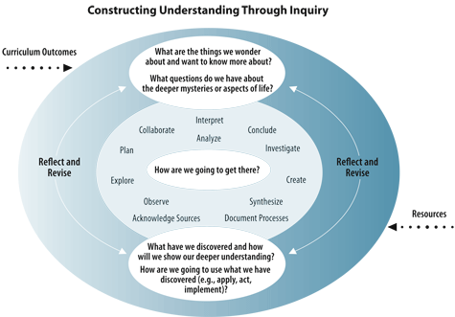
What is Inquiry?
“…is based on the belief that understanding is constructed in the process of people working and conversing together as they pose and solve the problems, make discoveries and rigorously test the discoveries that arise in the course of shared activity.” - Galileo.org
How does it work?
Teachers will use the provincial curriculum to guide the exploration of students in areas of interest and prior knowledge. The teacher establishes the Big Idea or Question with the students that relates to the unit being studied in the curriculum. The students, with guidance from the teacher, create essential questions that will help the students learn the important information (curricular indicators). The students will create their own learning plan that will involve quality research of the essential questions that will provide them with an understanding of the topic and Big Idea being focused on. The teacher will ensure students are moving towards a quality final assessment that they will share with an audience.
What’s the Difference?

To make sure we deliver quality multigraded instruction that will reach all students at all grade levels Bjorkdale School will be using the inquiry based education model that is encouraged by the Saskatchewan Ministry of Education.

