Printing A Class List
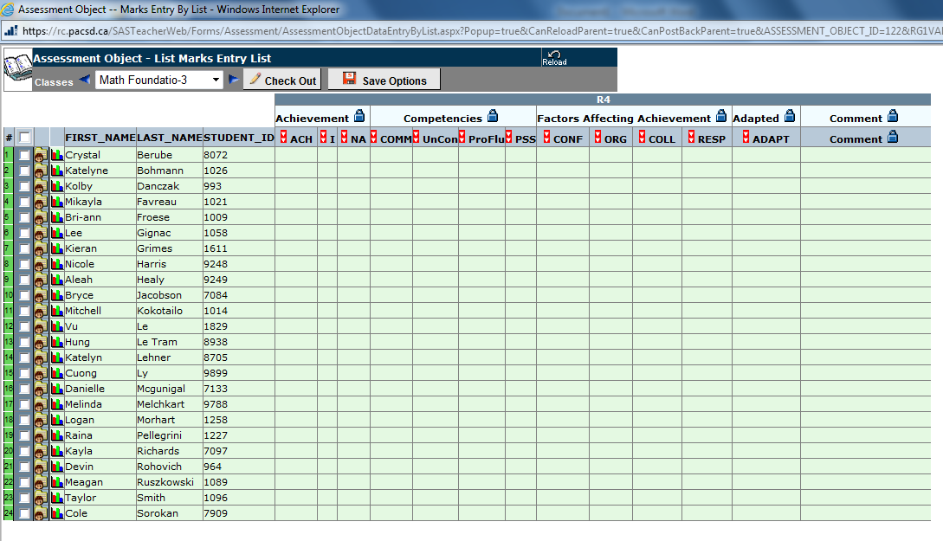
Just a reminder for progress report pilot or grade 9 teachers:
You can print a copy of your class list (works great to write your data in before you enter it, and when finished entering it, you can do the same for your verification sheets of what you entered) from the StudentsAchieve progress report by doing the following:
Once you have chosen the reporting period, make sure your class is checked in, then choose to view the class you need.

This window pops up that allows you to view all your students easily (without all the dropdown menus). Then if you click the right mouse button anywhere on the table ...

You get this menu that allows you to choose to Print... (lets you print as is), or Print preview... (which would allow you to change the orientation to landscape)

Choose Print preview... and then change the orientation from Portrait to Landscape (lots more room to write in your numbers)

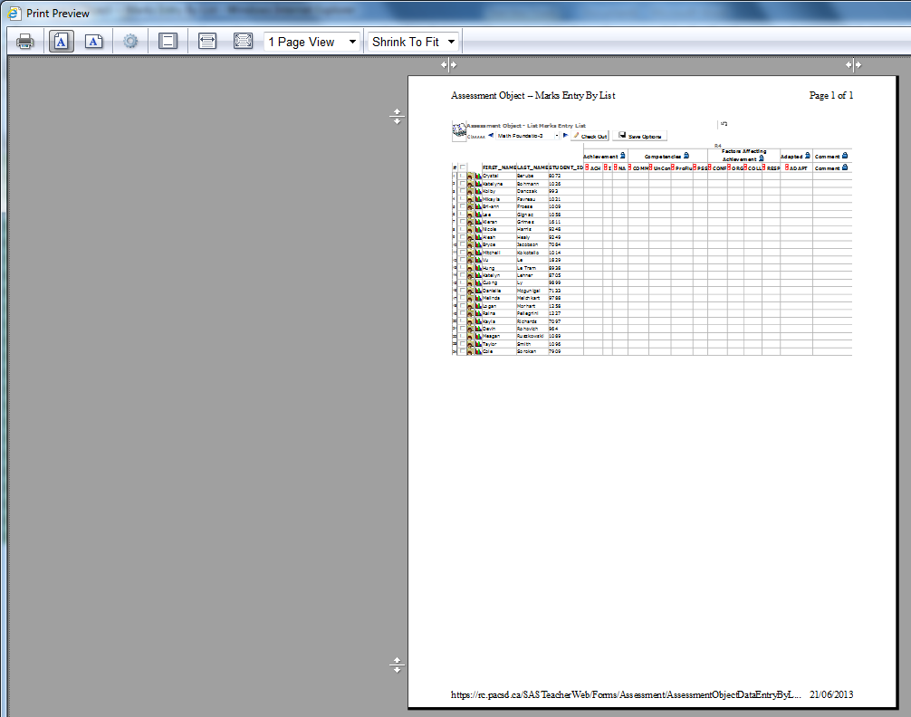
Although, you may want this view after you enter your data to print out your verification sheets.

This is the result of the printout. I find it works really well to write all the results in, the typing in the data is pretty quick since everything matches.
I hope it helps.
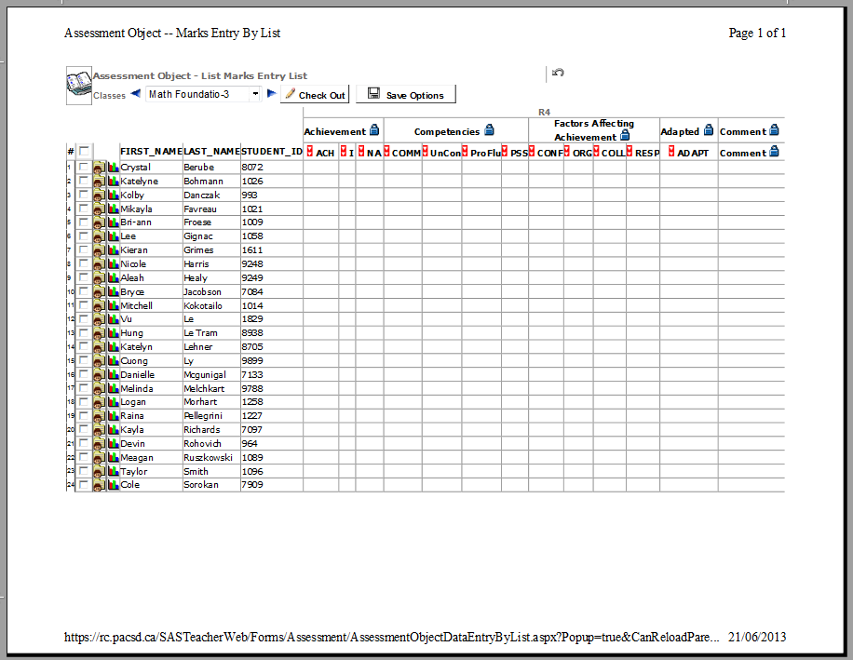

Let me know if you need any help doing this,
Murray.

