myBlueprint: Logging In and Exploring
- Access the myBlueprint website (link on right panel of school webpage: www.mysmhs.ca)
www.myBlueprint.ca/parcssd

- Log In with Username and Password

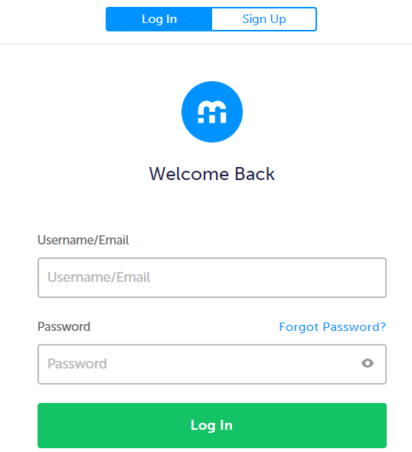

- Explore the Dashboard on the left panel of the screen.
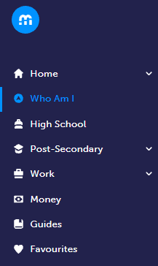

- Complete surveys: Who Am I?
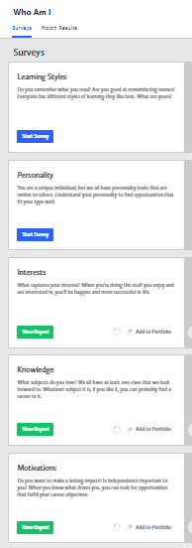
- Plan Courses: High School
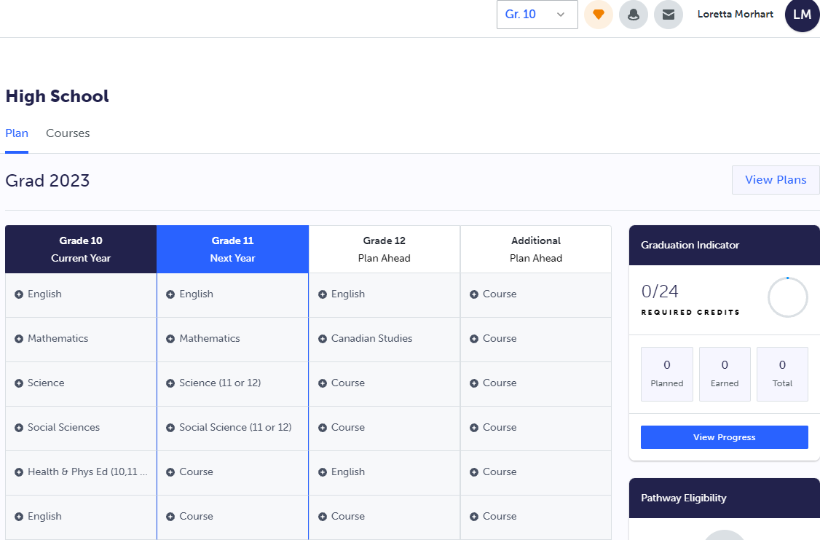

- Explore Post-Secondary Options: Apprenticeship, College & University, Workplace
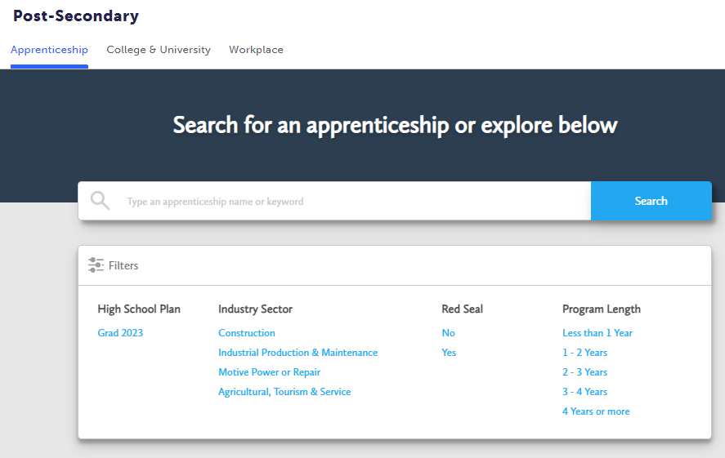

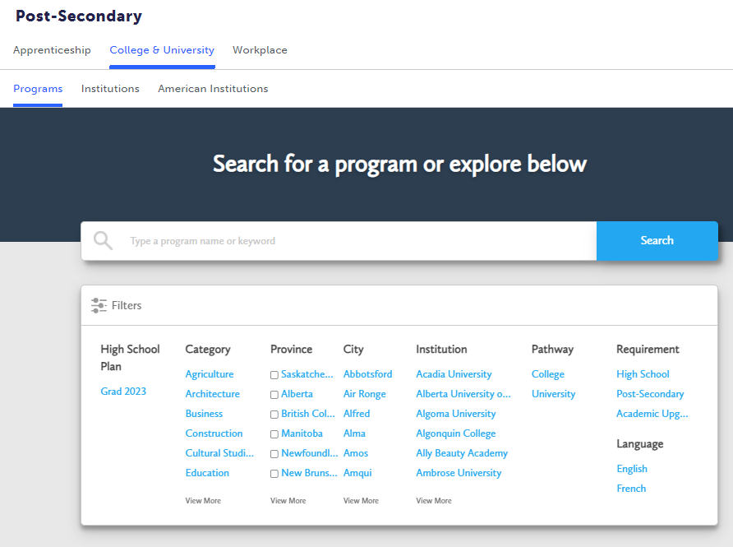
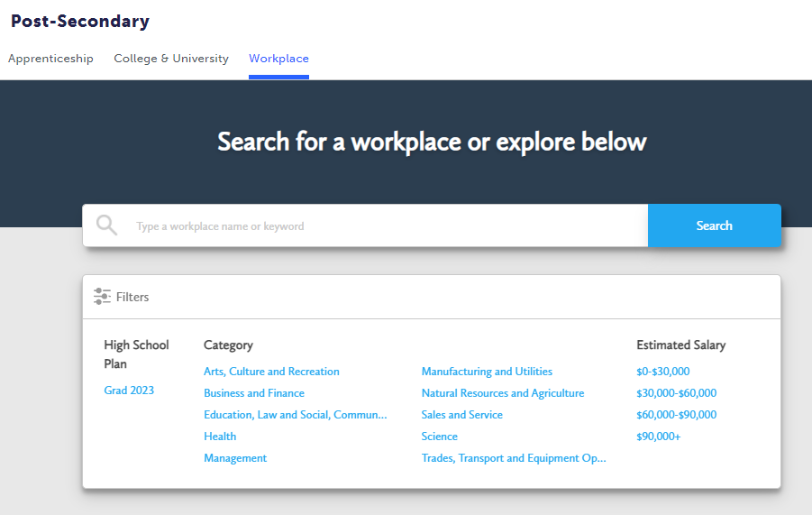

- Explore Work: Occupations, Resumes, Cover Letters, Job Search
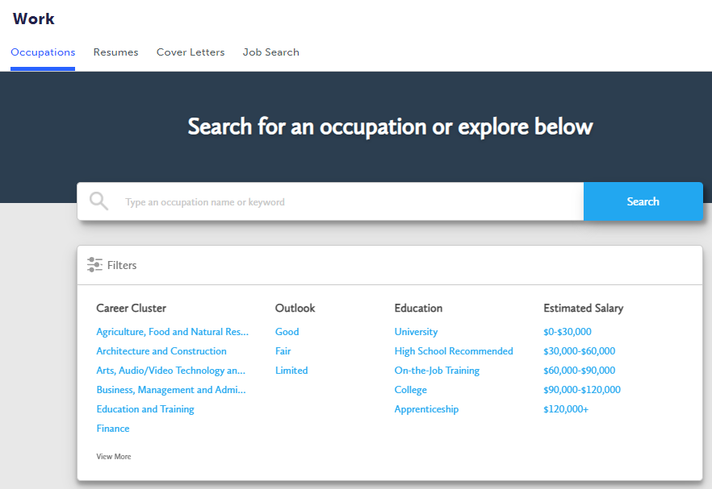
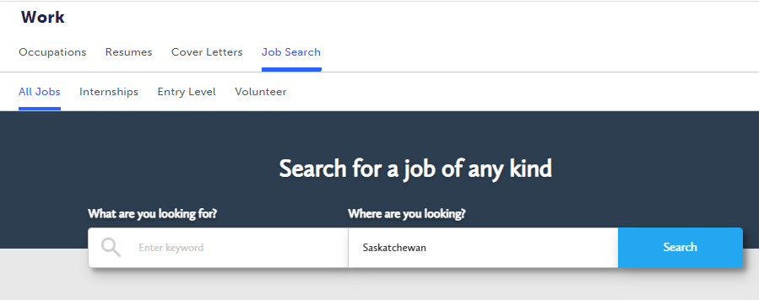

- Explore Money: Budget and Finance
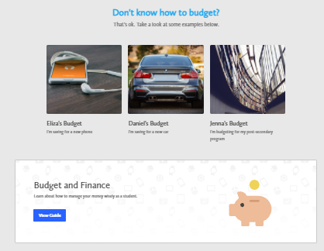

- Explore Guides for Additional Information
- Apprenticeship
- Budget and Finance
- College and University
- Cover Letter
- Disability Advisors: Post-Secondary Education Planning Information for Students with Disabilities
- Emerging Occupations
- Volunteering
- Working for Co-operatives
- Workplace

