myBlueprint
Creating an Account
- Access the myBlueprint website (link on right panel of school webpage: www.mysmhs.ca)
www.myBlueprint.ca/parcssd

- Select “Sign Up” to create an account.

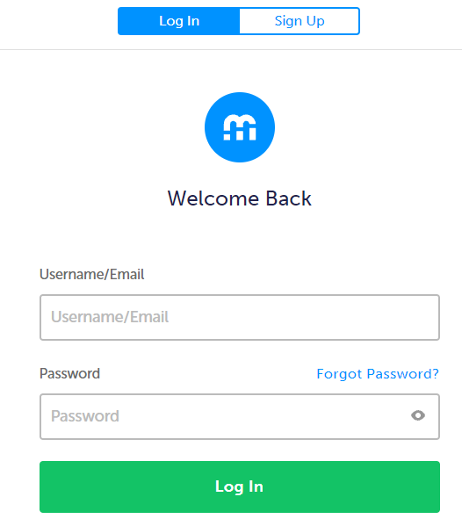
- Use the drop-down to select the School (PACSD Grade 10-12 or PACSD 6-9).
Then select “Create Account”.
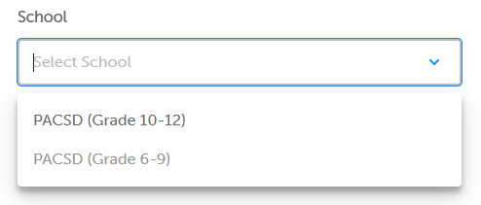

- Select “Student”.
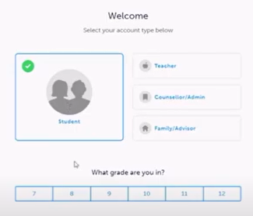

- Enter your 9-digit Learning ID number supplied by the Ministry of Education.
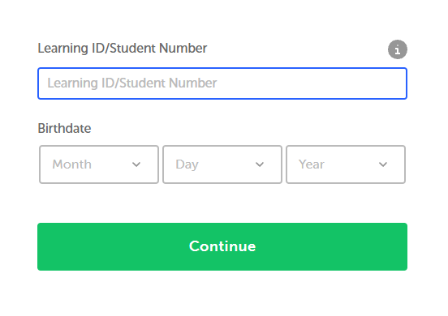

- Enter your school email and create a password. Also select the applicable language.
