

OPPORTUNITIES

Resumes

Summer

Jobs!

Work Skills

Learning



Youth Summer Job Finding Club

www.pacsc.com



Gain

Experience



Interview skills

Explore

Providing career and employment services to multi-barriered individuals aged 16 to 19.

Prince Albert Community Service Centre

Work Preparation

101-15th Street West

Prince Albert, SK. S6V3P7

(306)-953-4460

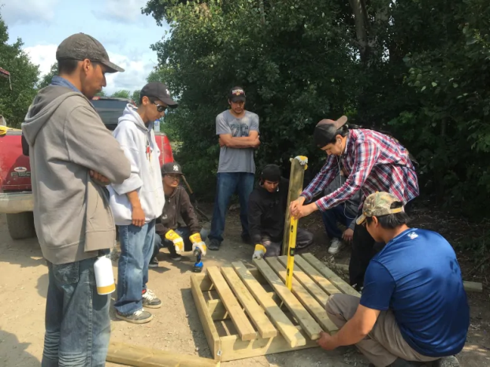

### Individual

Focus

Youth Summer Job Finding Club

**Where**?

101 – 15th Street West

Prince Albert

Across from Gateway Mall downtown.

Employability

Skills

**For more**

**information**



**Individual Attention**

**Participant Supports**



Youth Employment

Focused

**What Can We Do?**

We work to increase the self-confidence and participant needs to have long term employment and build for the career of their choice. Working together in a one-to-one environment we focus specifically on your needs.

Mark Krayetski

Vocational Counsellor

306-953-4486

m.krayetski@pacsc.com

Melanie Pederson

Vocational Counsellor

306-953 4471

m.pederson@pacsc.com

v



**How Can We Do It?**

On the first session, we will register and work on resumes. Second session we will finish resumes and work on interview skills, job leads and talk about the hidden job market! At the end of the two days, you will have a professional resume and be employment ready.

Classes are limited to six participants per session, so register soon to get the leg up on finding summer employment! Call or email at the information below to register!

**When?**

We have three sessions to choose from:

* Tuesday February 28 and Thursday March 2 from 4 p.m. to 6 p.m.
* Tuesday March 7 and Thursday March 9 from 4 p.m. to 6 p.m.
* Tuesday March 21 and Thursday March 23 from 4 p.m. to 6 p.m.

